02/10/2020

CMP4271 Professional Practice for Games Development

Task 1

1.0 Introduction

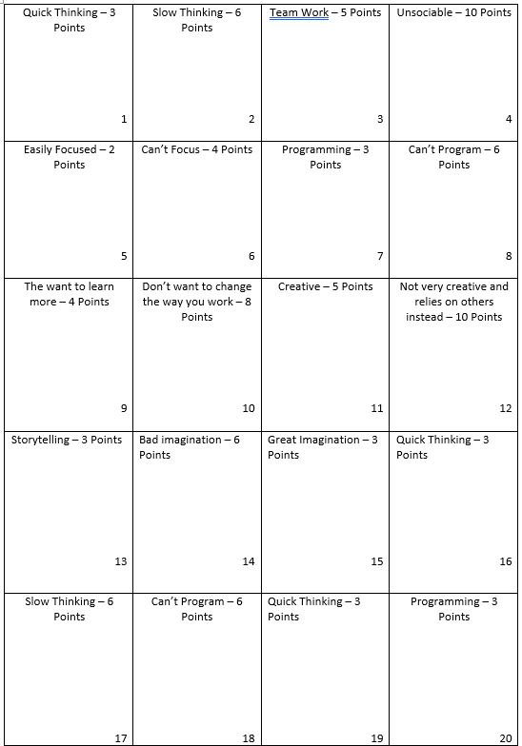The game today was about employability skills. The game my team came up with was based on the game Sheriff of Nottingham (<https://www.arcanewonders.com/wp-content/uploads/2017/06/Sheriff_of_Nottingham_Rulebook.pdf>). In our game, there is a group of people, one being the Employer and the rest being people applying for the job. You will get a selection of skill cards, good and bad, and you will use these to get points. To win the game, you must have the most points after a certain amount of rounds chosen by the player.

* 1. Materials

To make the game, you would need a stack of cards with good skills and bad skills (example shown above) and either point tokens or just a piece of paper to keep score.

* 1. Rules

1. Players will have six cards that contain both good skills and bad skills. Each cards will have points on, which will determine the winner at the end with the most points. Bad skill cards have twice the amount as the good skill cards.
2. The players can decide what cards they want to pass by the Employer without showing them what is on them . They then have to say what cards they have, but they will need to bluff if they want to get their illegal bad skills cards past. You cannot lie about the number of cards you put forward. It is up to the Employer to decide if they believe the Player.
3. If they believe the player, then they can get through and can top up on the points they earned at the end of the round. If the Employer decides to look at the cards and sees a bad skill, the player must give the employer points equalling to the amount of bad skills found. If the player has only good cards, then the employer must give the player points equalling to all the cards they tried getting through.
4. At the end, everybody must show what cards they have and the players who passed will get the points from their cards.
   1. Playtesting

This was not conducted

* 1. Discussion

From creating the game itself, we realised some mistakes that could have been fixed, such as the amount of points the player is given at the start and the points on the cards. We also rectified the game for those playing online as our group was all online. To play online, you bring up a D20 dice roll online and what number you get corresponds to the number at the bottom right of the cards.

1.5 Reflection

Some of the key employability skills I learned during this is teamwork, as we had little time and had to delegate roles, which is good to optimise our time, creativity and quick thinking because we only had an hour to make the game, play test it and make a presentation, so we needed to be quick and creative. Flexibility is also a key employability skill as you need to be flexible without time and make sure we hit deadlines.

The team I had worked with was Danyal Mahmood, Mohammed and Cory Arnett-O’Brien